1. Write your observations about the Classifier’s behavior with respect to the number of estimators

For most models, when n_estimator is 50, it has the highest accuracy score. And when the number of estimators increases, the accuracy rate decreases till number of estimators is around 250. And finally after the number of estimators reaches around 450, the accuracy rate increases again.

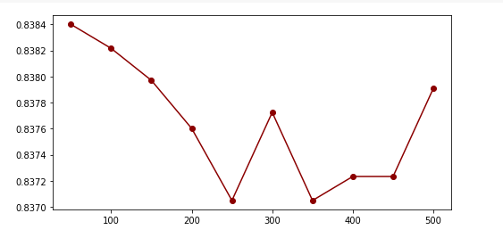

2. Is there an optimal value of the estimator within the given range?

The optimal value of the estimator is 100.